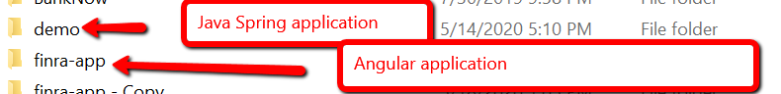

Spring Project structure

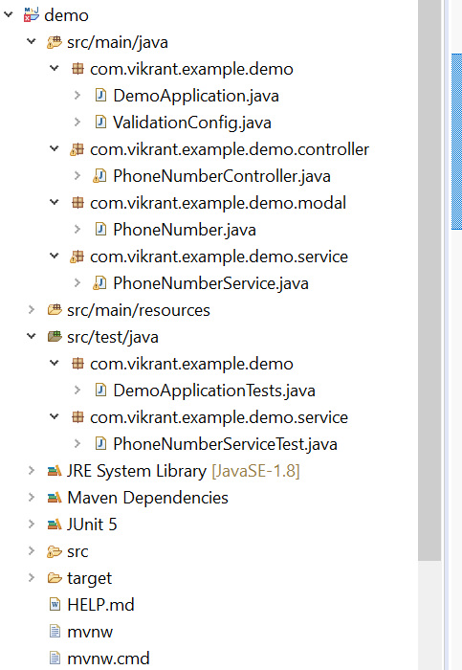

Application stack

* Spring Boot
* Spring REST
* Spring log back
* Annotations used

|  |  |
| --- | --- |
| @SpringBootApplication | Include build in tomcat and startup as java application for REST API |
| @Configuration | Stereotype for specifying configurations |
| @Bean | Bean definitions |
| @Service | Stereotype for specifying service classes |
| @RestController | Stereotype for specifying rest controller |
| @RequestMapping | Assign mapping to a method |
| @Validated | Error handling |
| @CrossOrigin | Allowing other origin requests to REST API |
| @NonNull @Size | Validation for path variable |
| @Test | Junits |

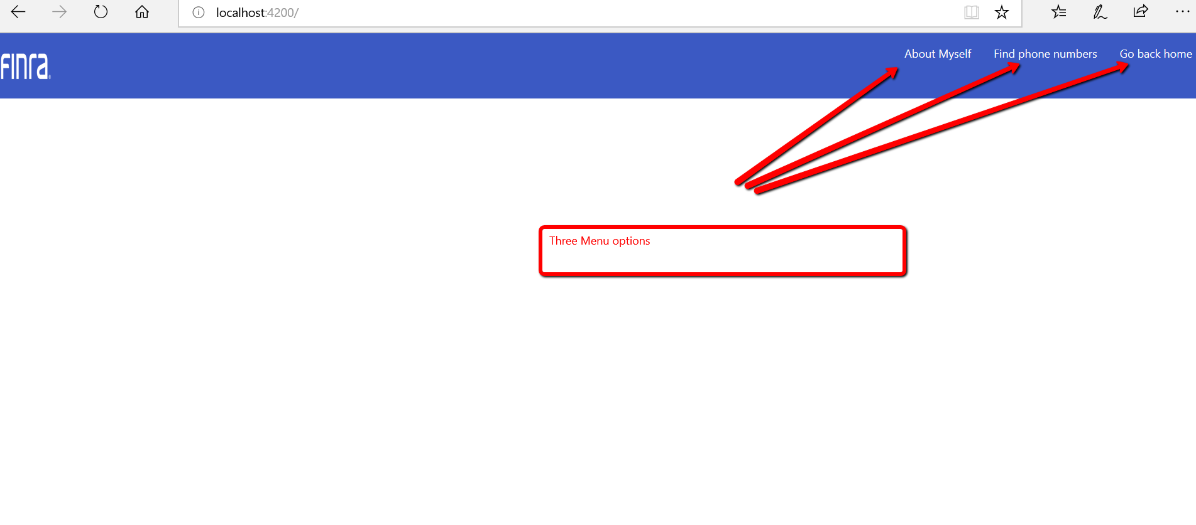

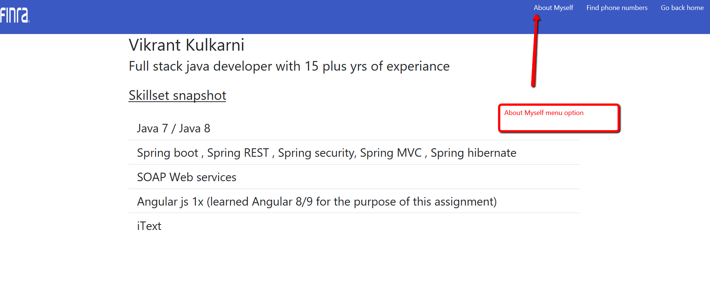

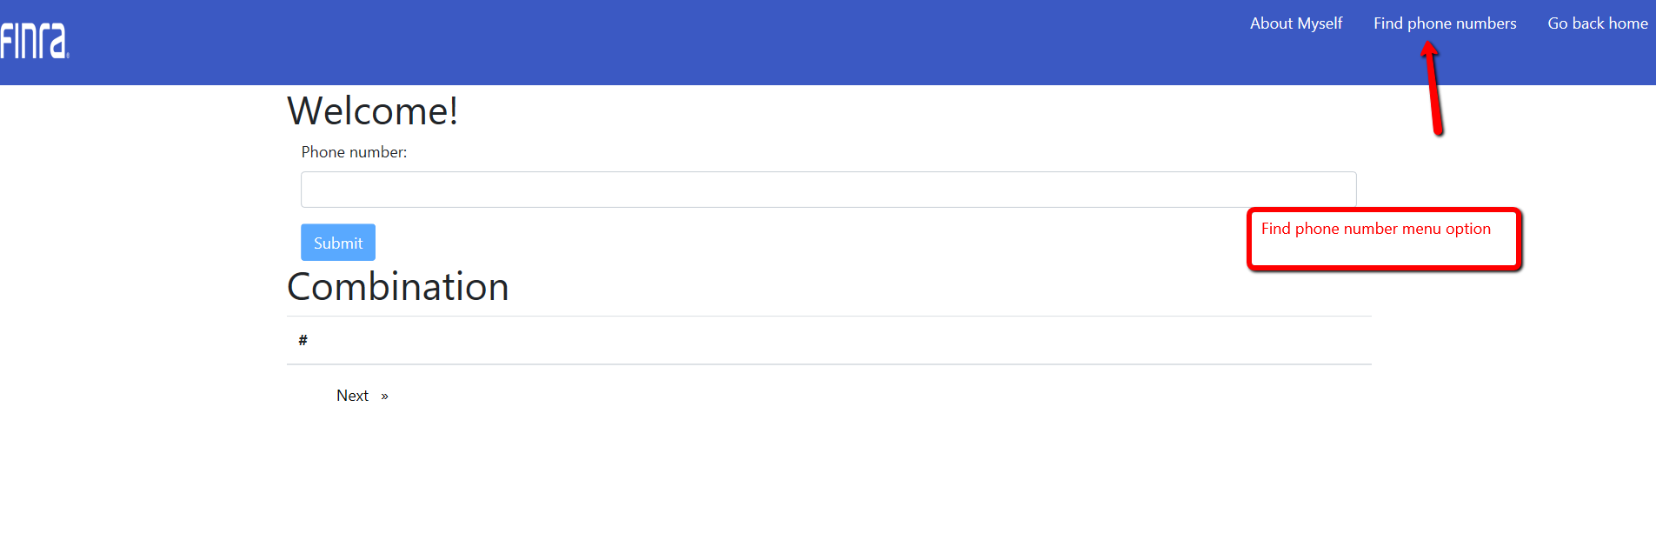Validations

